**LAB 5: Inheritance and Polymorphism**

1. WAP to implement the following form of inheritance.

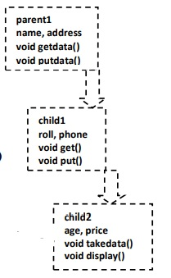

1. Create a class Cricketer with member variables to represent name, age and number of matches played. From this class derive two class bowler and batsman. Bowler class has number of wickets as member variable and batsman class has number of runs and centuries as member variables. Use appropriate member functions in all classes to read and display respective data.
2. WAP to illustrate the concept of function overriding.
3. WAP to implement the following form of inheritance:

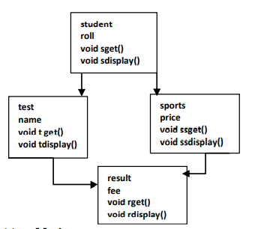

1. WAP in C++ to illustrate the execution order of constructors and destructors when both the base and derived class has constructor and destructor in single and multiple inheritances.